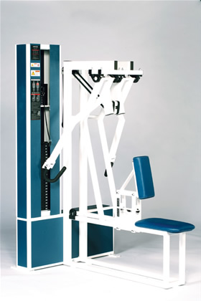Seated Row
- Handles and movement arms mimic the hands’ natural movement during the row exercise.
- Chest pad adjusts to allow tension at the start of the movement.
- 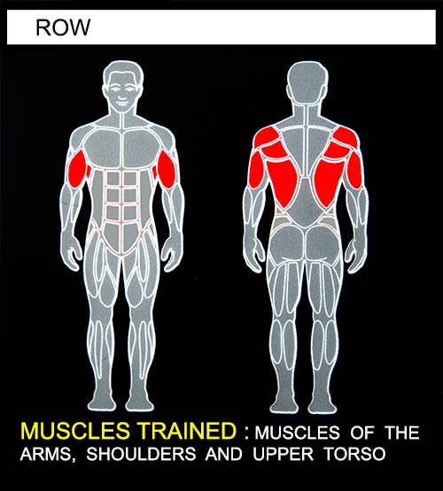Select a resistance with which you can perform 8 to 12 complete repetitions. While keeping your chest against the chest pad, pull the handlebars back as far as you can. Movement through full-range should take at least 4 seconds. Pause for 1 second and return to the starting position using a count of at least 4 seconds. Do not pause, immediately begin the next repetition. All movement should be controlled and deliberate. Avoid throwing or jerking the weight. Continue to exercise until you are unable to complete a repetition in good form.
COMMENTS - For best results, exercise should be performed throughout the greatest range of pain free movement.
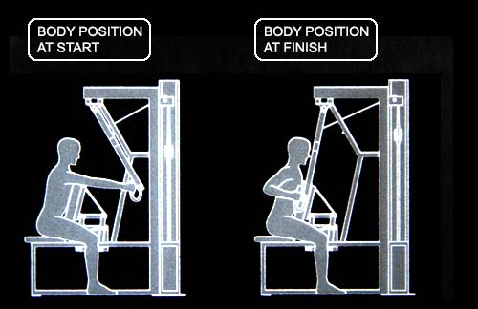

INSTRUCTIONS FOR AKINETIC TRAINING - Select a resistance which is approximately 2/3 the resistance you would use in normal training. Insert the limiter pin in the stack pin holes above the 20 lb. plates. Lift the weight slowly by pulling down with both hands until reaching the selected stop position. Keep the weight against the stop while alternately flexing one arm and extending the other. Perform the exercise in a smooth, deliberate fashion using 2 - 3 seconds per stroke. Continue the exercise until you are unable to keep the weight against the stop. Increases in resistance should be made as endurance increases.

