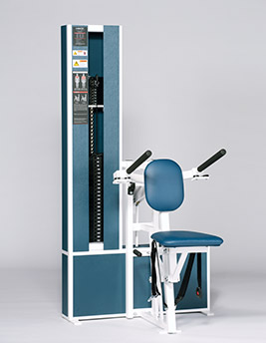Seated Dip
- Two position handles for all user sizes.
- Smooth and low-friction direct steel link design.
- Oversized handles for better hand comfort.
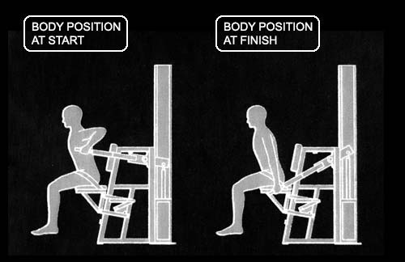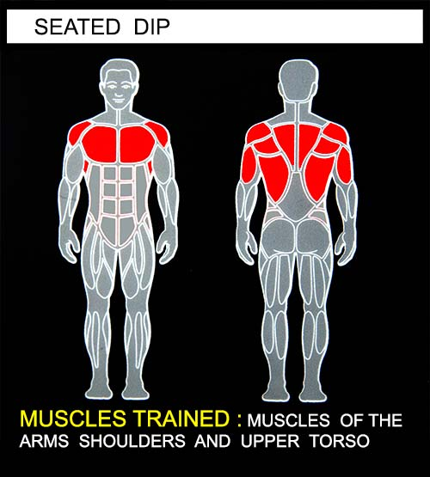Select a resistance with which you can perform 8 to 12 complete repetitions. Grasp the handlebars, lean forward and push the movement arm downward as far as you can. Movement through full-range should take at least 4 seconds. Do not pause with your arms in the locked out position. Return to the starting position using a count of at least 4 seconds. Do not pause, immediately begin the next repetition. All movement should be controlled and deliberate. Avoid throwing or jerking the weight. Continue the exercise until you are unable to complete a repetition in good form.
COMMENTS - For best results, exercise should be performed throughout the greatest range of pain free movement.
The starting position can be varied by removing the selector pin from the weight stack, moving the movement arm to the desired starting position and inserting the selector pin at the desired level of resistance.
Exercise and muscle movement can be modified by leaning backward while exercising. This position increases the amount of triceps involvement.

