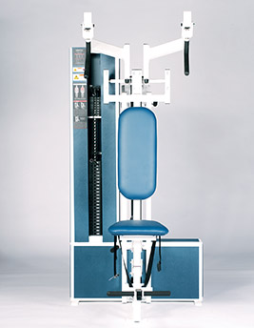Torso Arm
- Four-position adjustable handles increase the versatility of the workout.
- Arms may be used in unified movement or individually to increase control.
- Assist pedal allows pre-stretch and easy start.

- EXERCISE - Select a resistance with which you can perform 8 to 12 complete repetitions. Grasp the handlebars and pull the movement arms as far down as you can. Movement through full-range should take at least 4 seconds. Pause for 1 second and return to the starting position using a count of at least 4 seconds. Do not pause, immediately begin the next repetition. All movement should be controlled and deliberate. Avoid throwing or jerking the weight. Continue the exercise until you are unable to complete a repetition in good form.
COMMENTS - For best results, exercise should be performed throughout the greatest range of pain free movement.
