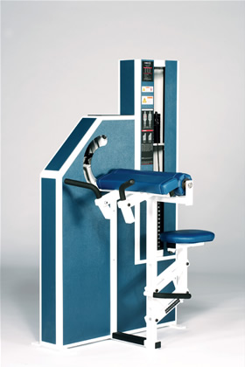Bicep Curl
- Forearm pad aligns movement axes without pressure on chest.
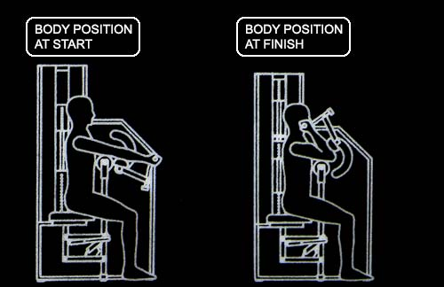
- Ergonomically designed handles for natural arm positioning.

EXERCISE - Select a resistance with which you can perform 8· to 12 repetitions.· While maintaining an open-handed grip on the handlebars and without moving your elbows. rotate the movement arm toward you as far as possible. Movement through full range should take at least 4 seconds. Pause for 1 second and return to the starting position using a count of at least 4 seconds. Do not pause. Immediately begin the next repetition. All movement should be controlled and deliberate. Avoid throwing or Jerking the weight. Continue the exercise until you are unable to complete a repetition in good form.
COMMENTS - For best results. exercise should be performed throughout the greatest range of pain free movement.
The starting position can be varied by removing the selector pin from the weight stack. moving the movement arm to the desired starting position and Inserting the selector pin at the desired level of resistance.
Similar Instructions -
- Position body as shown in diagram above.
- Select a resistance with which you can perform from 8 to 1 2 repetitions.
- Lift the weight smoothly and slowly by bending your arms. The lifting phase should take approximately 2 seconds.
- Pause for 1 second while under load.
- Lower the weight smoothly and deliberately for a count of 4 seconds.
- DO NOT PAUSE BETWEEN REPETITIONS.
- Attempt another repetition if you completed your effort IN GOOD FORM.

