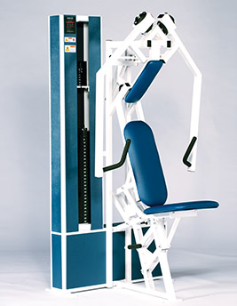Chest Press
- Movement converges at the end of the stroke, exercising the pectorals over a wider range of motion.
- Synchronized movement arms allow maximum utilization of muscular effort.
- Adjustable seat and back pad for optimal positioning.
- Strategic designed handles for multiple hand positions.
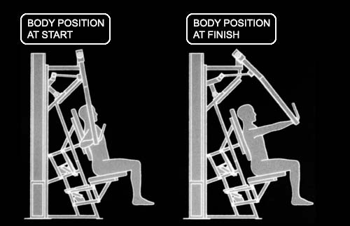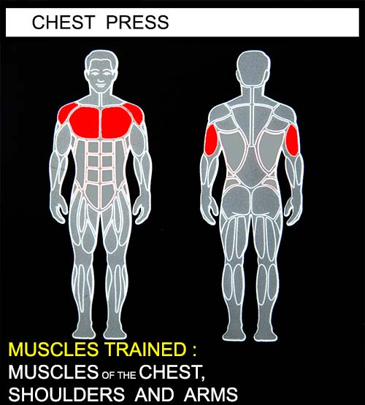EXERCISE - Select a resistance with which you can perform 8 to 12 complete repetitions. Push the movement arms as far forward as you can. Movement through full-range should take at least 4 seconds. Do not pause with your arms in the locked-out position. Return to the, starting position using a count of at least 4 seconds. Do not pause, immediately begin the next repetition. All movement' should be controlled and deliberate. Avoid throwing or jerking the weight. Continue the exercise until you are unable to complete a repetition in good form.
COMMENTS - For best results, exercise should be performed throughout the greatest range of pain free movement.
Exercise and muscle involvement can be modified by varying the movement arm starting position and by varying the hand position on the handlebars.

