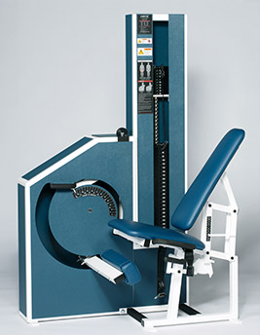Leg Extension
- Seat designed to maximize efficiency of exercise and to ensure proper joint alignment through the full range of motion.
- Movement and seat support design allow for greater range of motion.
- Assist handle allows for easy entry into machine.
- Goniometer (angle detector) enables observation of proper range of motion.
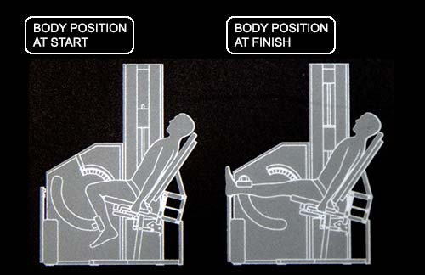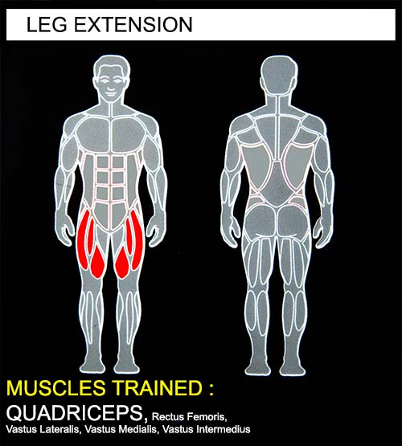EXERCISE - Select a resistance with which you can perform 8 to 12 complete repetitions. Lightly grip the handlebars beside the seat to reduce upper body movement and maintain proper position. Extend both legs smoothly. Movement through full extension should take at least 4 seconds. Pause for 1 second and return to the starting position using a count of at least 4 seconds. Do not pause, immediately begin the next repetition. All movement should be controlled and deliberate. Avoid throwing or jerking the weight. Continue the exercise until you are unable to complete a repetition in good form. (Do not grip handlebars tightly with hands).
COMMENTS - For best results, exercise should be performed throughout the greatest range of pain free movement.
The range of movement can be limited in extension, flexion or both. To limit extension, insert the auxiliary selector pin in one of the weight stock pin holes above the bottom weight stack. To limit the range in flexion, pull the selector pin from the weight stack and move the movement arm to the desired starting position and insert the selector pin at the desired level of resistance.
An injured limb support can be positioned to provide support for an injured limb while allowing for full-range exercise of the uninjured limb.
A hand lever assists machine entry/exit and adjusting range of motion.

